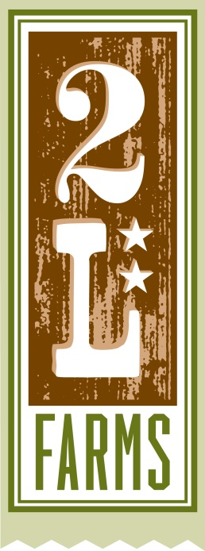
Grass Fed Beef Roast

1 – 3 lb. grass-fed beef roast
5 carrots, chopped
1 large onion chopped
4 ribs celery, chopped
2 cups good red wine
2 cups beef stock
2 bay leaves, optional
2 large sprigs fresh rosemary (or 2 tsp. dried, crushed)
1 tsp. dried thyme
2 tsp. sea salt
2 tsp. black pepper
2 tsp. garlic powder (or you could use 4 cloves fresh garlic, minced)

Start by combining the salt, pepper, thyme and garlic powder.
Rub the roast with a couple teaspoons of oil and sprinkle the seasonings liberally on the roast on all sides. Rubbing the oil on the roast instead of adding to the pan will reduce spatters. Let sit at room temperature for at least half an hour.

Preheat the oven to 350 degrees.

Heat a heavy pot on medium high heat. Add the roast and brown on all sides. You’re looking to get a nice caramelized color on all sides. Once browned, remove the roast to a plate and add your vegetables to the pot. If the sweating of the vegetables doesn’t help you scrape up all the yummy brown bits, add a bit of the wine to help.

Once the vegetables have begun to soften, add the roast back to the pan and add the wine, stock, rosemary and bay leaves.

Bring the pot to a gentle simmer on the stove then cover tightly and place in the oven. My roast took 2 hours to get to the tenderness I like which is not falling apart but slices nicely and is fork tender and delicious. If you prefer it more well done it may take up to 3 hours.

